# 

### **CE3606 :: JavaScript 2: Advanced JavaScript for websites and Web Applications**

# 

# 

# 

# 

# 

# Lecture 9

## **Exercises sheet**

## **Aristos Markogiannakis**

## 

## **Please use these notes together with my lecture presentation.**

**Exercise 1 – Components and Properties**

The following steps we will follow to build our first react app.

**Step 1**

To avoid the burden of doing the webpack configuration we can simply install the

Create React App – More info can be found below

<https://reactjs.org/docs/create-a-new-react-app.html>

For now, what we need to do

Open the Visual Studio and then

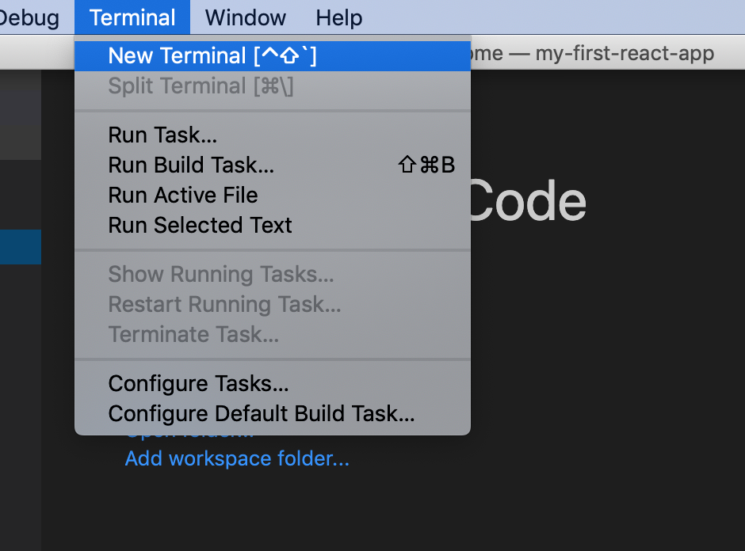

In terminal type the following:

**Step 1a:**

npx create-react-app my-first-react-app

**Step 2**

Let’s create our first component

Open the folder you have created in Visual Studio.

Run **npm start** in terminal

Once you do this you should be able to see

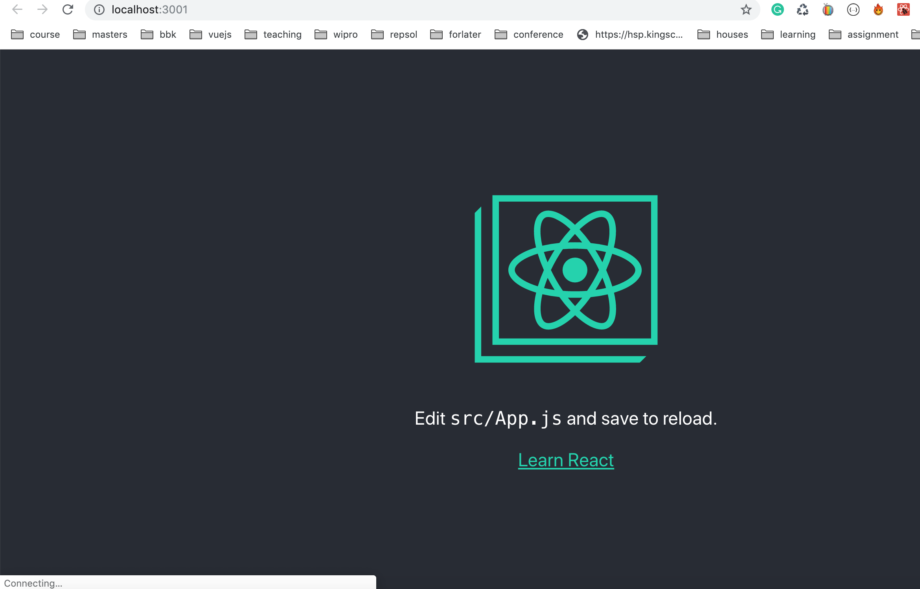

**Step 3**

Inside the folder **src** create a folder called **Student**

**Step 4**

Create a file called **Student.js**

**Step 5**

Copy the following code to your **Student.js**

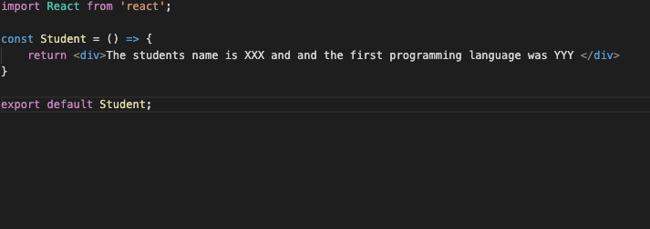

**Step 6**

Modify the App.js file as per the following image

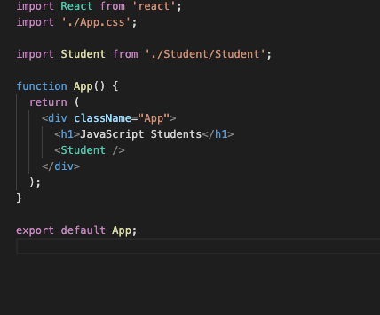

You can see now the following:

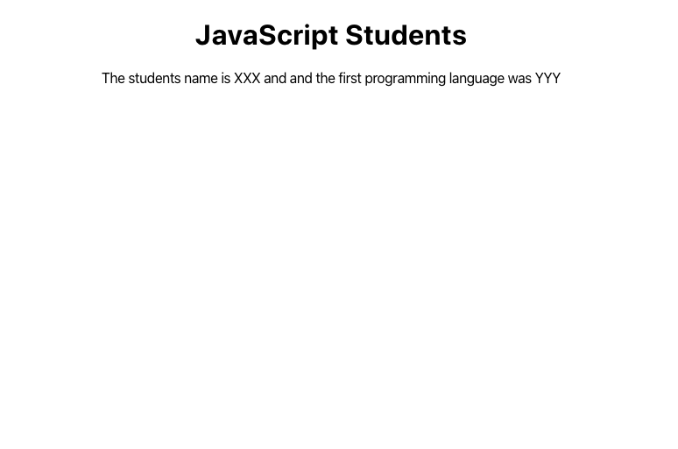

**Step 7**

We will modify the Student and App.js to add properties to reuse our Student component.

First modify the App.js based on the image below

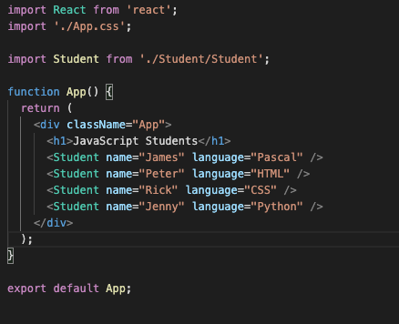

And then the Student.js

t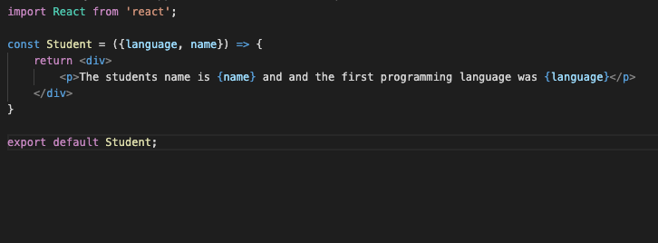

You should get the following in your screen

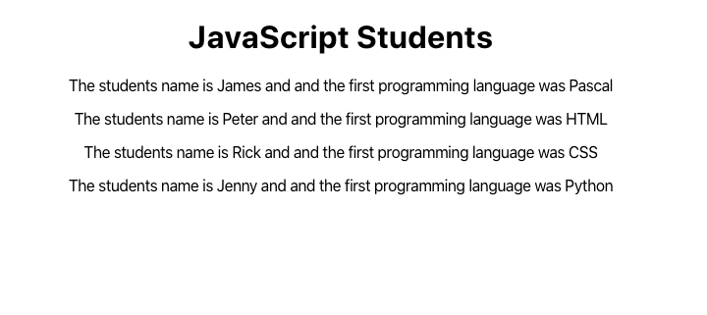

**Homework**

Time to do the try the same as well.

1. Create a component called Teacher
2. The component should have a property called name, and one called teaches
3. Add the component in App.js and pass the following values
   1. Name: ‘Aris’
   2. Teaches: ‘JavaScript, HTML, CSS, and PHP’

It should output the following

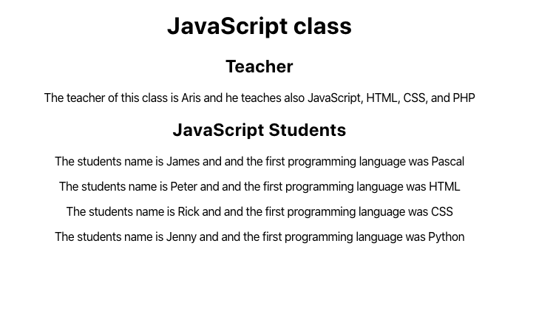

**Exercise 2 – State**

We will now modify the App.js as per the following image

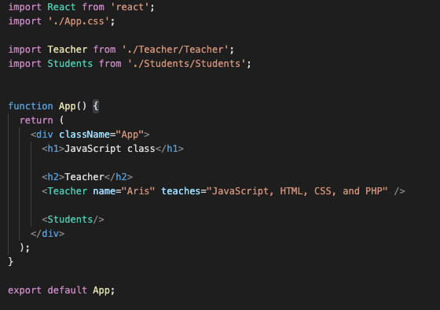

We will then create a Students component in the src directory

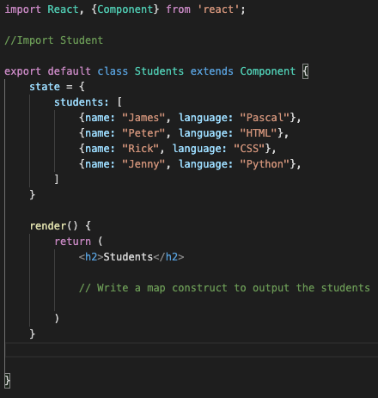

Fill in the gaps:

A) Import the component Student inside this i

B) Write a map construct to output the students

**Hint for B:**

The code should be like the following image

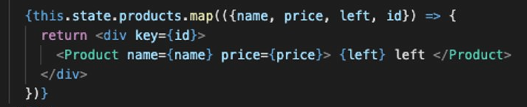

Also, you will need to modify the students to add an id for each student

The result should be the same as before